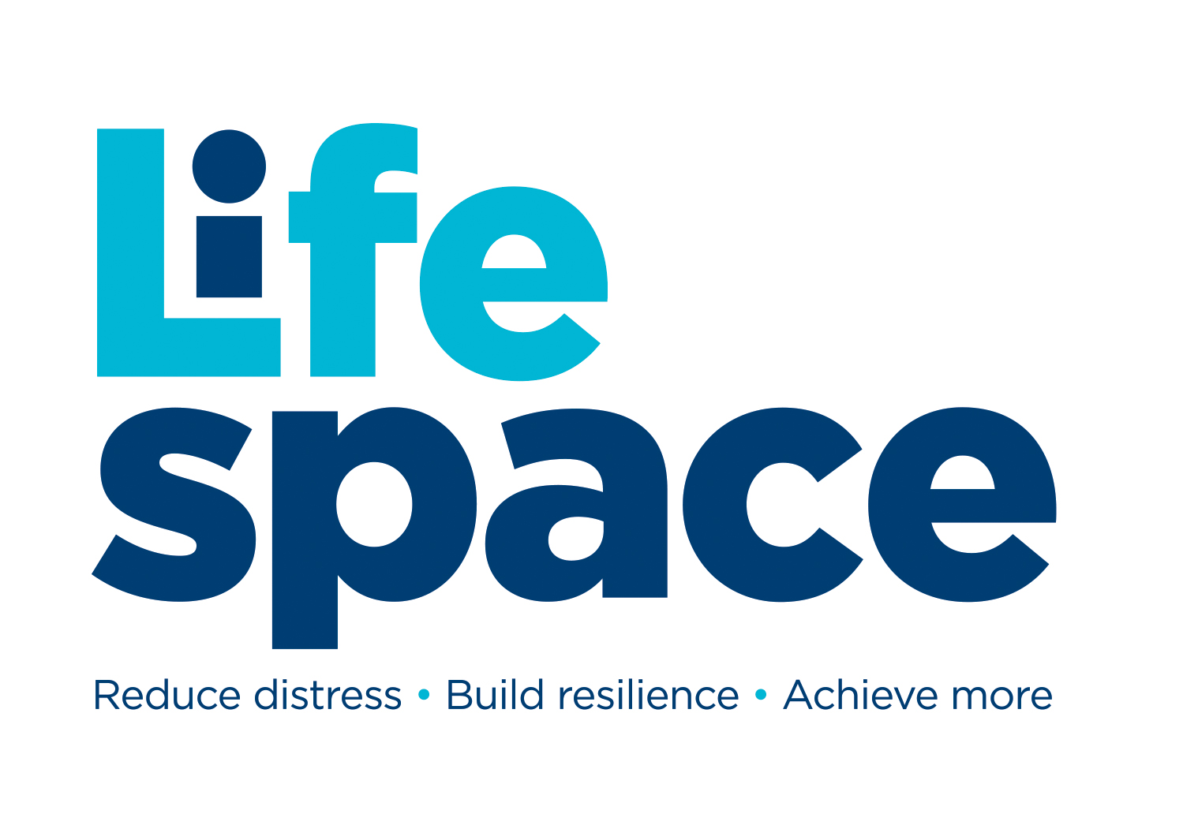
COMMUNITY
ONE TO ONE MENTORING REQUEST FORM
“We mentor young people to reduce distress, build resilience & achieve more”

If you are 16 or over you may self-refer. If you are 15yrs or younger parental consent is required. Once completed return this form to hello@lifespace.org.uk

TELL US ABOUT YOURSELF/THE YOUNG PERSON

Full Name
Preferred Name
Pronouns
Gender
Date of Birth
Preferred session type | Face to Face / Phone / MS Teams / Any of these (please delete as appropriate)
Your/young person’s current address
Do you/they have a Stratford home postcode | Yes/No (please delete as appropriate)

PARENT CARER CONTACT INFORMATION
If you are 16yrs or over you can provide your own contact details but if you are younger, this information needs to be that of your Parent/Carer or other responsible adult

Full Name
Contact number
Contact email
Contact address (if different to above)

TELL US ABOUT YOUR/THEIR REASONS FOR REQUESTING MENTORING
This section should be completed by or with the person who is to be mentored.
The reasons for requesting mentoring? (Please include as much information as you can)

Are there any major events that have happened in your life that you would like us to be aware of? (e.g. Bereavement, trauma, mental health)

RISK ASSESSMENT
Have you or the young person you are completing this on behalf of: | Never | Past 1-4 weeks | Past 1-6 months | Past 6-12 months | More than a year ago
Harmed yourself/themselves
(include use of alcohol/drugs):
Been harmed by others:
Inflicted harm on others:
Experienced loss:
Had thoughts of suicide:
Witnessed Domestic Abuse:

HEALTH INFORMATION
Doctor Surgery name
Doctor Surgery number
In relation to your health or medication, is there anything that would be useful for us or a medical professional to know (e.g. Any health, allergies, medication or medical conditions)

EMERGENCY CONTACT INFORMATION - This must be a responsible adult (required for all referrals regardless of age). We will only use this information in an emergency situation.

1st Emergency contact: |  | 2nd Emergency contact:
Name |  | Name
Telephone |  | Telephone
Email |  | Email
Address |  | Address

Sign here to confirm information given is correct:
Your Signature (digital is fine)
Date

Parent or carer consent if aged 15 or under:
Your Name: |  | Relationship to the young person:
Signature: |  | Date:

TERMS, CONDITIONS AND PRIVACY POLICY
- If we consider it necessary in order to safeguard and/or promote a young person's welfare, we will contact DSL at school and/ or other agencies
- Ordinarily we will seek the young person’s consent (or parent's/carer's consent as necessary) but there may be occasions we do not, if doing so places young person at risk or causes delay
- The information shared on this form is strictly confidential and is only for the attention of Lifespace Trust. Its is not to be shared & must be stored securely.

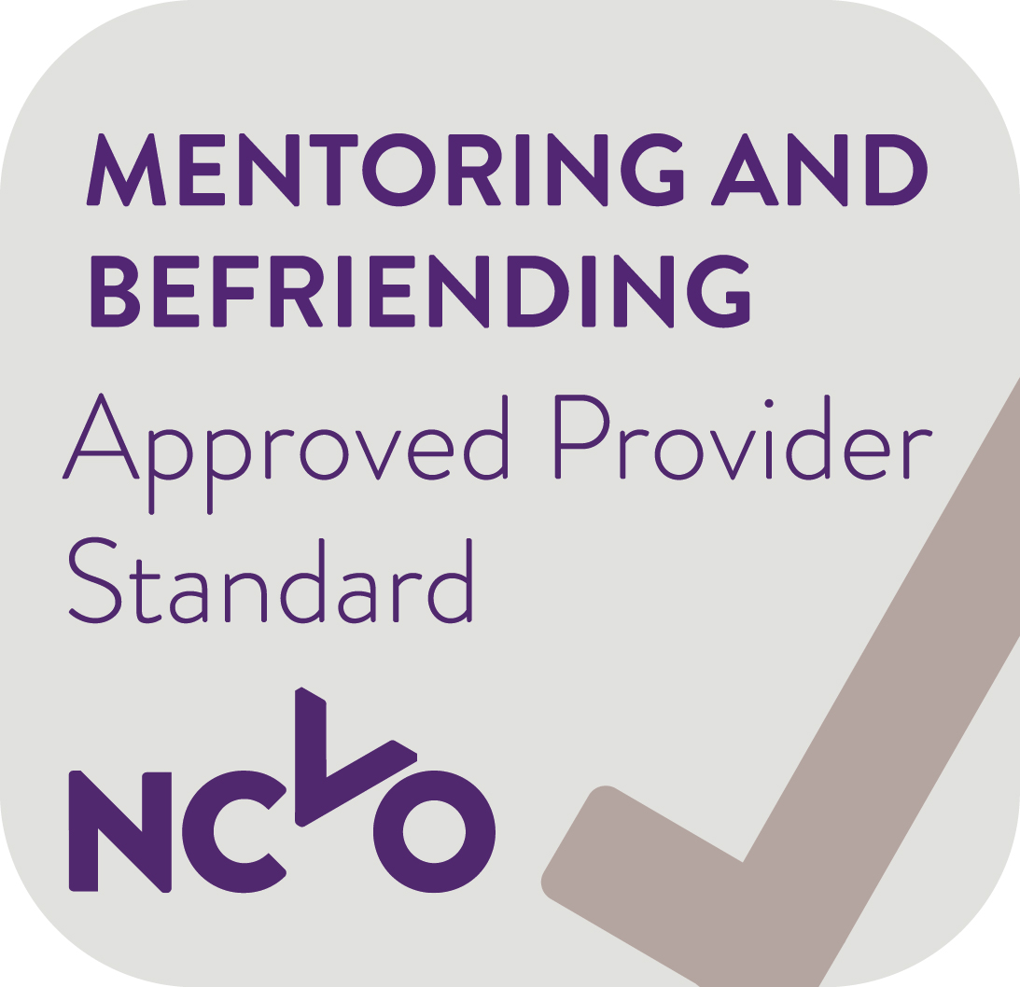
Lifespace Trust, Tyler House, Tyler St, Stratford-Upon-Avon, Warks. CV37 6TY
Tel: 01789 297400 Email: admin@lifespace.org.uk Web: www.lifespace.org.uk
Lifespace Trust is an Approved Provider & has been awarded The Queen’s Award for Voluntary Service

